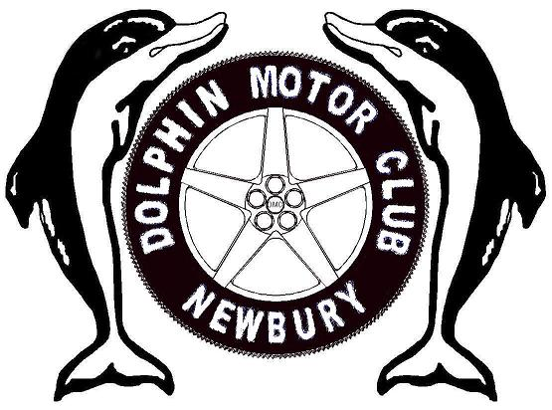

NEWBURY DOLPHIN MOTOR CLUB

MEMBERSHIP APPLICATION

Membership Form

Membership Fees: (Tick box as applicable)

Full Single/joint £15.00
Single event only £5.00

Full Name:
Address:

Post Code:
E-Mail:
Home Phone:
Mobile Phone:

For Joint Membership
Full Name:

Total Remittance : £

Payment should be made via BACS, Account number – 70212121 Sort Code – 20-59-14 use your surname as the reference

I/We agree to be bound by the rules laid down by the Dolphin Motor Club (Newbury) Ltd. I/We also agree to the above information being held on the membership computer listing (as required by the Data Protection Act 1984)

Signed: ……………………………………………………………

Date: …………………………

Please return all completed forms to the club membership secretary:
Mark Nicoll
Riverside House
Enborne Row
Wash Water
Newbury
RG20 0LX
Tel: 01635 42529

